QR Based Restaurant Menu System Using ReactJS
¹N.V.Ashok Kumar,²S. Rama Devi, ³N. Bhuvana, ⁴M. Anusha, ⁵B. Vamsi,
¹Associate Professor, ^{2,3,4,5}Students
^{1,2,3,4,5}Computer Science And Engineering (AI&ML),
^{1,2,3,4,5}Avanthi Institute of Engineering and Technology , Makavarapalem,531113

Abstract
The rapid growth of digital technologies has transformed traditional restaurant management systems. Conventional menu systems require physical interaction between customers and waiters, which may lead to delays, miscommunication, and inefficiencies in order processing. The QR Based Restaurant Menu System is a web-based application developed using ReactJS that enables customers to access restaurant menus by scanning a
QR code. The system allows customers to browse menu items, place orders digitally, and send them directly to the restaurant staff. Administrators can manage menu items, register waiters, create table IDs, and monitor orders and bills. This digital approach reduces physical contact, improves order accuracy, and enhances overall restaurant service efficiency. The system provides a user-friendly interface and streamlines restaurant operations while improving customer experience.
Keywords: QR Code, ReactJS, Restaurant Management System, Digital Menu, Web Application

1. Introduction
Restaurants traditionally rely on printed menus and manual order-taking methods, which can lead to operational inefficiencies and delays in service. With the increasing demand for contactless services and digital solutions, many restaurants are adopting technology-driven systems to improve their operations.
A QR-based menu system allows customers to scan a QR code using their smartphones to access the restaurant's digital menu. This eliminates the need for physical menus and reduces the workload of waiters. The system enables customers to browse food items, select dishes, and place orders directly from their devices.
The QR Based Restaurant Menu System developed using ReactJS simplifies restaurant management by integrating digital ordering, menu management, and billing processes. The system improves service speed, minimizes errors, and enhances the overall dining experience.

2. Literature Survey
Several restaurant management systems have been developed to improve efficiency and reduce manual operations.
Traditional restaurant systems rely heavily on human interaction for order placement and management. These systems often face issues such as order miscommunication, delays, and difficulty managing large customer volumes.
Recent advancements in web technologies have enabled the development of digital restaurant management systems. QR-based systems allow customers to access menus directly through smartphones, eliminating the need for printed menus.
Cloud-based restaurant systems provide centralized management, allowing administrators to update menus, monitor orders, and manage staff operations efficiently. These systems improve operational accuracy and reduce service time.
However, many existing systems are complex and expensive to implement. The proposed QR Based Restaurant Menu System focuses on simplicity, efficiency, and accessibility for small and medium-sized restaurants.
Recent studies highlight the importance of digital transformation in the restaurant industry to improve service efficiency and customer satisfaction. Many researchers have proposed web-based restaurant management systems that automate menu display, order processing, and billing operations. QR code technology has been widely adopted because it enables customers to access digital content quickly through smartphones without installing additional applications.
Several systems have implemented QR codes to provide contactless menu access, especially after the increased demand for hygiene and safety in public places. These systems help restaurants reduce physical menu handling and improve operational efficiency. Researchers have also explored the integration of web technologies such as ReactJS, Node.js, and cloud-based databases to create responsive and scalable restaurant applications.
Some studies focus on improving order management by integrating real-time updates between customers and restaurant staff. Other research emphasizes enhancing user experience through intuitive interfaces and faster order processing. These advancements demonstrate that QR-based digital menu systems are an effective solution for modern restaurant environments, offering improved convenience for both customers and restaurant management.

3. Proposed System
The proposed system is a web-based application developed using ReactJS that enables digital access to restaurant menus through QR codes. The system allows customers to view menu items, select food, and place orders directly using their smartphones. This approach eliminates the need for traditional printed menus and reduces manual order-taking by waiters. The system improves communication between customers and restaurant staff while ensuring faster service and better order management.
The system consists of three main user roles:

Admin
The administrator manages the entire system. The admin can register waiters, create table IDs, manage menu items, and monitor orders and billing information. The admin has full control over the system and is responsible for maintaining the restaurant database.
The admin can add new food items, update prices, remove unavailable dishes, and organize menu categories. This helps keep the digital menu updated at all times. The administrator can also track customer orders and analyze restaurant performance based on order records. By maintaining the system, the admin ensures smooth operation and better management of restaurant activities.

Waiter
Waiters are responsible for confirming orders placed by customers and updating the order status. They also assist in finalizing customer bills. The waiter acts as a bridge between the customer and the restaurant kitchen.
Once a customer places an order through the digital menu, the waiter verifies the order and sends it to the kitchen for preparation. Waiters can also update the order status when the food is ready to be served. This process helps reduce confusion and ensures that customers receive their food quickly and accurately.

Customer
Customers scan a QR code placed on the table to access the digital menu. They can browse food items, add them to their cart, and place orders directly through the system. This provides a convenient and contactless way of ordering food.
Customers can view detailed information about each menu item, including price and description. They can modify their order before confirming it and track the status of their order. This improves customer satisfaction and reduces waiting time.
This system improves operational efficiency and provides a seamless dining experience for customers. It reduces manual workload for restaurant staff, minimizes order errors, and enhances overall service quality. The digital menu system also promotes faster service and better communication between customers and restaurant staff.

4.System Architecture
The architecture of the QR Based Restaurant Menu System consists of three main components:
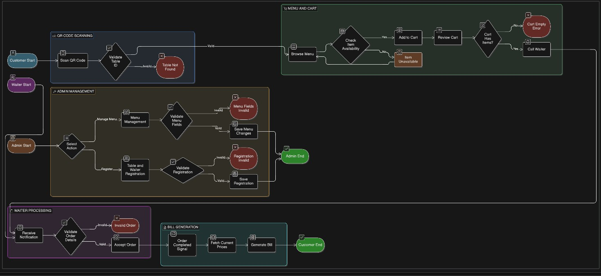
Fig.1 Flowchart for QR-based Restaurant menu.

Frontend
Developed using ReactJS to provide an interactive and responsive user interface for customers, waiters, and administrators. The frontend is responsible for displaying the digital menu, handling user interactions, and sending requests to the backend server.
It provides a user-friendly interface where customers can browse food items, view descriptions and prices, and add items to their cart. The frontend ensures smooth navigation and quick response using modern web technologies such as HTML, CSS, and JavaScript. ReactJS components help in creating reusable UI elements, improving the performance and maintainability of the application.
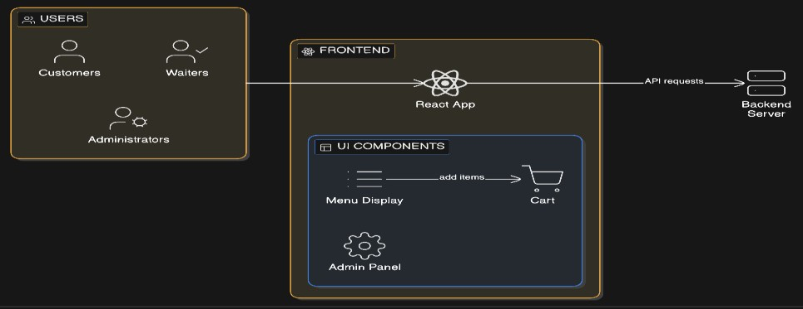
Fig.2 Frontend Flowchart

Backend
The backend handles data processing, authentication, order management, and communication between system components. It processes requests sent from the frontend and performs the necessary operations such as retrieving menu data, storing orders, and updating order status.
The backend also manages user authentication for administrators and waiters to ensure secure access to the system. It controls the flow of information between the frontend and the database, ensuring that all customer orders and updates are processed accurately and efficiently.
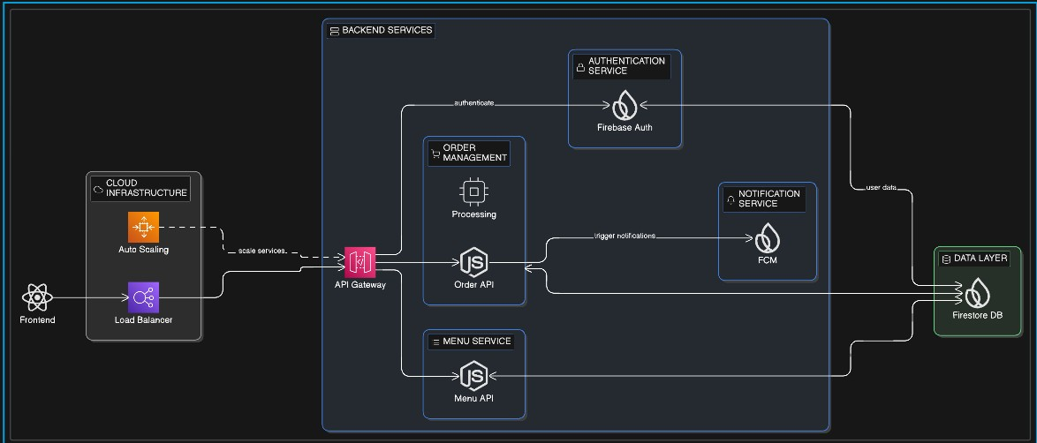
Fig.3 Backend Flowchart

Database
The database stores menu items, order details, user information, and billing records. It acts as the central storage system for all application data.
The database allows administrators to easily update menu items and monitor order history. It also stores transaction records, which helps restaurants track sales and analyse business performance. Using a structured database system ensures that data is organized, secure, and easily retrievable when required.
Customers access the system by scanning QR codes, which redirect them to the digital menu interface. Orders are transmitted to the backend server and processed by the restaurant staff. The backend then stores the order information in the database and updates the order status accordingly.
This architecture ensures smooth communication between different components of the system. It enables realtime data processing and provides a reliable platform for managing restaurant operations efficiently
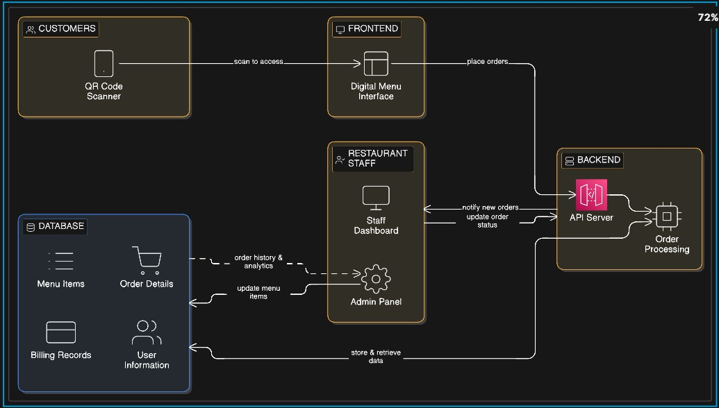
Fig.4 Backend Flowchart

5. Implementation
The system is implemented using modern web development technologies.
Frontend Technology
- ReactJS
- HTML
- CSS
- JavaScript
Backend Technology
- Node.js
- Express.js
Database
- FireBase
The ReactJS framework provides a dynamic user interface that updates in real-time as customers interact with the system. The backend handles authentication, order processing, and communication with the database.

6. Advantages of the System
The QR Based Restaurant Menu System provides several advantages:
- Contactless menu access
- Reduced waiting time for customers
- Improved order accuracy
- Easy menu management for administrators
- Enhanced customer experience
- Reduced paper usage

7. Review & Discussion
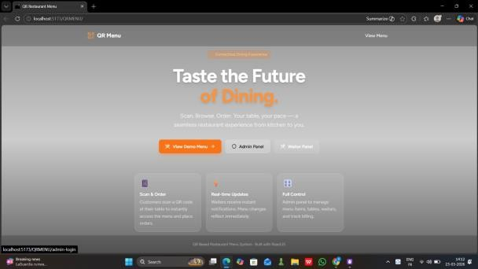
Fig.5 gateway interface
- ADMIN’S SIDE :

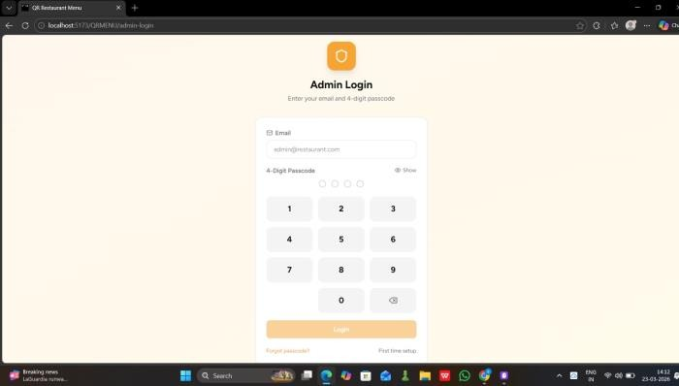
Fig.6 Admin Login
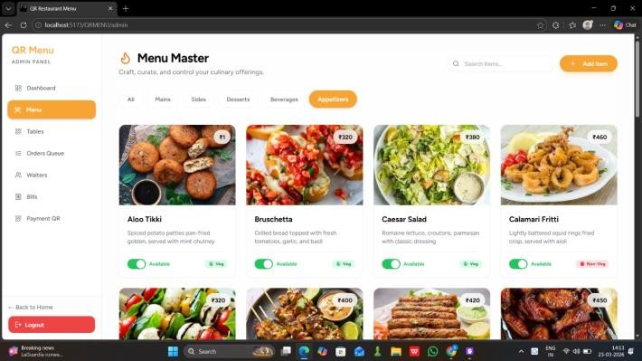
Fig.7 Manage Menu
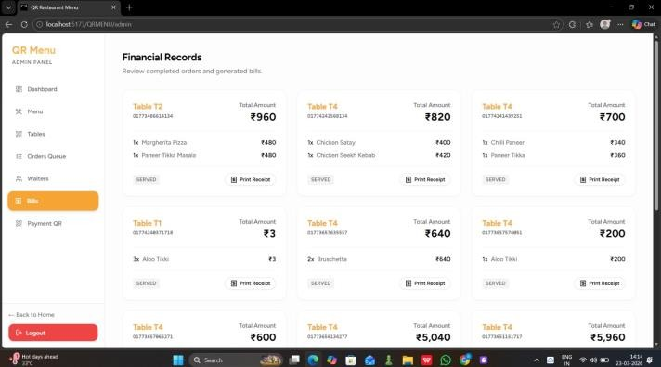
Fig.8 Manage Bills
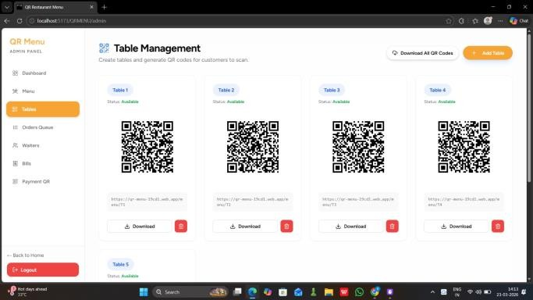
Fig.9 Manage Tables
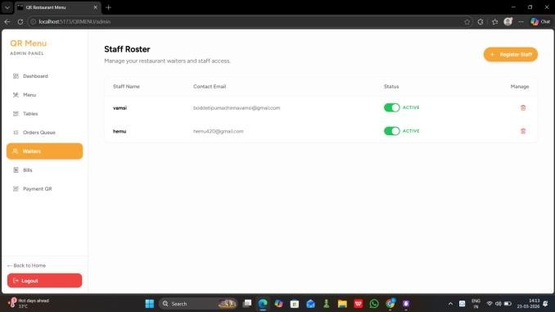
Fig.10 Manage Waiters

Fig.11 Manage Bills

Fig.12 Manage Tables

Fig.13 Manage Waiters

- CUSTOMER’S SIDE :
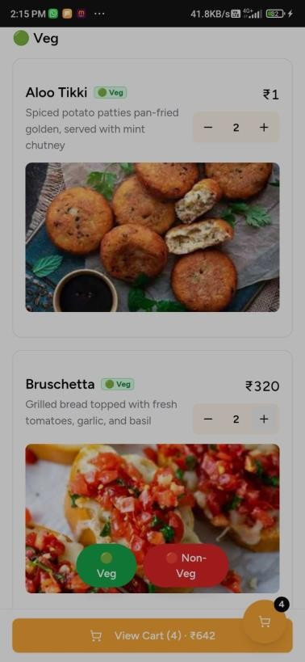
Fig.14 Ordering Menu Items

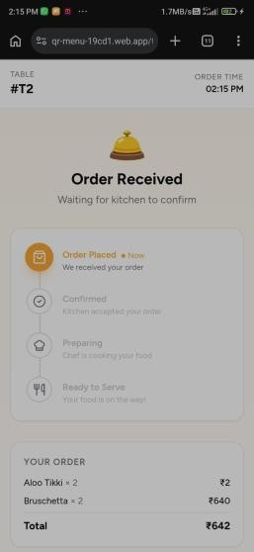
Fig.15 Order Tracking
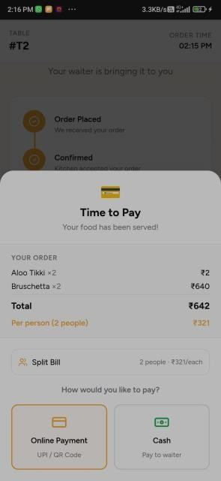
Fig.16 Payment Popup
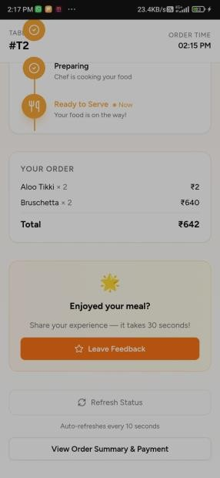
Fig.17 Manage Waiters

8. Conclusion
The QR Based Restaurant Menu System using ReactJS provides an efficient and modern solution for restaurant management. By integrating QR code technology with a web-based application, the system simplifies menu access and order placement for customers.
The system reduces manual work for restaurant staff while improving service speed and accuracy. It also promotes contactless interactions, which are increasingly important in modern dining environments. By replacing traditional printed menus with digital menus, the system helps restaurants maintain better hygiene and reduce paper usage.
In addition, the system improves communication between customers and restaurant staff, ensuring that orders are processed quickly and accurately. The digital ordering process minimizes human errors and helps restaurants handle a larger number of customers efficiently. The system also allows administrators to easily manage menu items, monitor orders, and maintain billing records.
Overall, the QR Based Restaurant Menu System enhances customer satisfaction by providing a faster, more convenient, and user-friendly ordering experience. It also helps restaurants improve operational efficiency and adopt modern digital solutions.
Future improvements may include online payment integration, real-time order tracking, and AI-based recommendations to further enhance the system's capabilities. Additional features such as customer feedback systems, table reservation options, and analytics dashboards can also be implemented to make the system more advanced and beneficial for restaurant management.

References
[1] K. Khairunnisa, A. Johari, M. Wahab, M. Erdi, M. Ayob, A. Ayob, “The Application of Wireless Food Ordering System”, MASAUM
Journal of Computing, vol. 1, no. 2, pp. 178-184, 2009.
[2] D. Sharma, “A Review of QR code Structure for Encryption and Decryption Process”, International Journal of Innovative Science and
Research Technology, vol. 2, no. 2, pp. 13-18, 2017.
Culture,
Lapland
[3] J. Qianyu, “Exploring the Concept of QR Code and the Benefits of Using QR Code for Companies”, Bachelor’s Thesis, School of Business
and University of Applied Sciences, Rovaniemi, https://www.theseus.fi/bitstream/handle/10024/85796/JI%20QIANYU-FINAL%20THESIS.pdf?sequence=1. Finland,
2014.
[4] M. Sadiku, T. J. Ashaolu, A. Ajayi-Majebi, S. Musa, “Big Data in Food Industry”, International Journal of Scientific Advances, vol. 3, no. 3,
pp. 148 – 152, 2020. doi: 10.51542/ijscia.v1i3.5.
[5] H. Smaya, “The Influence of Big Data Analytics in the Industry”, Open Access Library Journal, vol. 9, no. 2, pp. 1-12, 2022. doi:
10.4236/oalib.1108383.
[6] P. L. Bokonda, K. Ouazzani-Touhami N. Souissi, “Predictive analysis using machine learning: Review of trends and methods”,
International Symposium on Advanced Electrical and Communication Technologies (ISAECT), Marrakech, Morocco, 2020, pp. 1-6. doi:
10.1109/ISAECT50560.2020.9523703.
[7] Yhofoodie, Yhofoodie – About Us, 2018. http://yhofoodie.com/content/details_4_13.html.
[8] S. Kelly, Sakae Sushi First iPad Ordering System in Malaysia, 2019. https://www.sunshinekelly.com/2011/10/sakae-sushi-first-ipad
ordering-system.html.
[9] MA Venture Marketing, My QR Menu – About Us, 2021. https://qrmenu.my/.
[10] Google Charts, Google Chart Tools – QR Codes, 2022. https://developers.google.com/chart/infographics/docs/qr_codes.
[11] Yellowfin, FusionCharts Suite XT – jQuery Charts, 2023. https://www.fusioncharts.com/jquery-charts?framework=jquery.
[12] R. Boggarapu, Dynamic Data Visualization with Data Visualization with PHP
https://www.kdnuggets.com/2016/03/dynamic-data-visualization-php-mysql.html.
[13]OpenStax,“Linear Regression”,Introductory Business Statistics and
https://openstax.org/books/introductory-business-statistics/pages/13-4-the-regression
MySQL: (Version 2.0), Election Spending, OpenStax equation?query=linear%20regression&target=%7B%22index%22%3A0%2C%22type%22%3A%22search%22%7D#eip-851.
[14] A. Kondas, PHP-ML: Machine Learning library for PHP, 2022. https://php-ml.readthedocs.io/en/latest/. 2023.CNX, 2022.
[15] N. Abdul Latiff, “The Effect of Workplace Spirituality on Employee Performance”, Issues and Perspectives in Business and Social Sciences
(IPBSS), vol. 1, no. 1, pp. 22–27, 2021. doi: 10.33093/ipbss.2021.1.3.
[16] R. Kannan, “Leveraging Business Data Analytics and Machine Learning Techniques for Competitive Advantage: Case Study Evidence
from Small Businesses”, International Journal of Management, Finance and Accounting (IJOMFA), vol. 2, no. 1, pp. 73–87, 2021. doi: 10.33093/ijomfa.2021.2.1.3.

